**Use case 7**

**Domain: Aviation**

**Case- Competitive Dynamic pricing with AI in Aviation**

**Problem:**

Airlines face the challenge of maximizing revenue on each flight by adjusting ticket prices in real-time to meet demand fluctuations, competition, and various other factors. Traditional pricing strategies are often too static to respond quickly to changing market conditions. Following method shows how airline uses AI to collect data from competitor’s website to maintain market.

**Data Collection**

* **Identification of Competitor Websites**: Airlines start by identifying the websites of their competitors, including other airlines or online travel agencies (OTAs) that sell tickets for similar routes or flights.
* **Crawling and Scraping**: Web scraping tools and software are used to crawl the identified websites. These tools navigate through the competitor websites, accessing various pages to collect relevant data. This data can include information on fares, flight schedules, seat availability, and promotional offers.
* **Data Extraction**: Once the web scraping tool accesses the competitor's web pages, it extracts the desired data. This often involves parsing the HTML content of the pages to extract specific information such as pricing details, flight routes, departure times, and seat availability.
* **Data Storage and Analysis**: The scraped data is then stored in a structured format, typically in a database or data warehouse. Airlines use this collected data for analysis and decision-making. For instance, they can compare their own pricing and availability with that of competitors in real-time.
* **Real-Time Monitoring**: To stay competitive, airlines often set up web scraping scripts or bots to continuously monitor competitors' websites. This real-time monitoring allows them to quickly respond to changes in pricing or other relevant information.
* **Alerts and Notifications**: Airlines can set up automated alerts or notifications triggered by specific conditions. For example, if a competitor lowers its fare below a certain threshold, the airline's system can send alerts to pricing analysts or revenue managers.
* **Price Matching and Strategy Adjustments**: Airlines use the data collected through web scraping to adjust their pricing strategies. If a competitor offers a lower fare for a particular route, the airline may choose to match that price or adjust its pricing strategy to remain competitive.

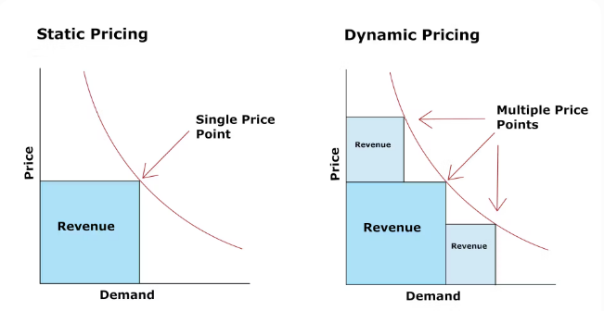

**Conclusion**

In conclusion, AI in demand prediction for dynamic pricing in airlines enables more accurate and responsive pricing strategies, leading to increased revenue and improved customer satisfaction. It allows airlines to stay competitive in a dynamic market by leveraging real-time data and advanced machine learning techniques.